Bottom of Form

Lab Syllabus

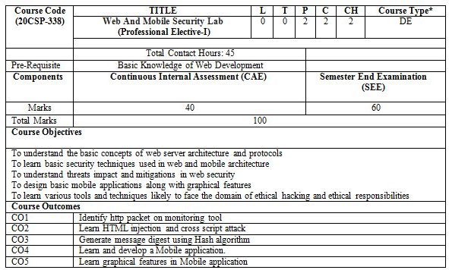

UNIT-I

1. Open any website on computer system and identify http packet on monitoring tool like Wireshark.
2. Design a method to simulate the HTML injections and cross-site scripting (XSS) to exploit the attackers.
3. Implementation of Cross site request forgery (XSRF) attack.
4. Implementation of Design methods to break authentication schemes (SQL Injection attack).

UNIT-II

5. Write a program to generate message digest for the given message using the SHA/MD5 algorithm and verify the integrity of message.

6. Perform Penetration testing on a web application to gather information about the system (Foot Printing).

7. Implementation of Session hijacking attack on http enabled website.

UNIT-III

8. Write a program to sign and verify a document using DSA algorithm.

9. Develop a Mobile application to create a notification in Android.

10. Create animations and graphical primitives in Android environment.